12. React-HOL
GuestPage.js
import React from 'react';

const GuestPage = () => {
return (
<div>
<h2>✈️ Guest View: Browse Flights</h2>
<ul>
<li>Indigo - Chennai to Delhi - ₹4000</li>
<li>SpiceJet - Bangalore to Mumbai - ₹3500</li>
<li>Air India - Coimbatore to Hyderabad - ₹4500</li>
</ul>
</div>
);
};

export default GuestPage;
UserPage.js
import React from 'react';

const UserPage = () => {
return (
<div>
<h2>👤 User View: Book Tickets</h2>
<p>Welcome! You can now book your flight tickets below:</p>
<button>Book Flight</button>
</div>
);
};

export default UserPage;
App.js
import React, { useState } from 'react';
import GuestPage from './GuestPage';
import UserPage from './UserPage';

function App() {
const [isLoggedIn, setIsLoggedIn] = useState(false);

const handleLogin = () => {
setIsLoggedIn(true);
}

const handleLogout = () => {
setIsLoggedIn(false);
}

let pageContent;
if (isLoggedIn) {
pageContent = <UserPage />;
} else {
pageContent = <GuestPage />;
}

return (
<div style={{ padding: '20px' }}>
<h1>🎟️ Ticket Booking App</h1>

{/* Login / Logout Buttons */}
{isLoggedIn ? (
<button onClick={handleLogout}>Logout</button>
) : (
<button onClick={handleLogin}>Login</button>
)}

<hr />
{/* Conditional Page Content */}
{pageContent}
</div>
);
}

export default App;
Output:
Login:
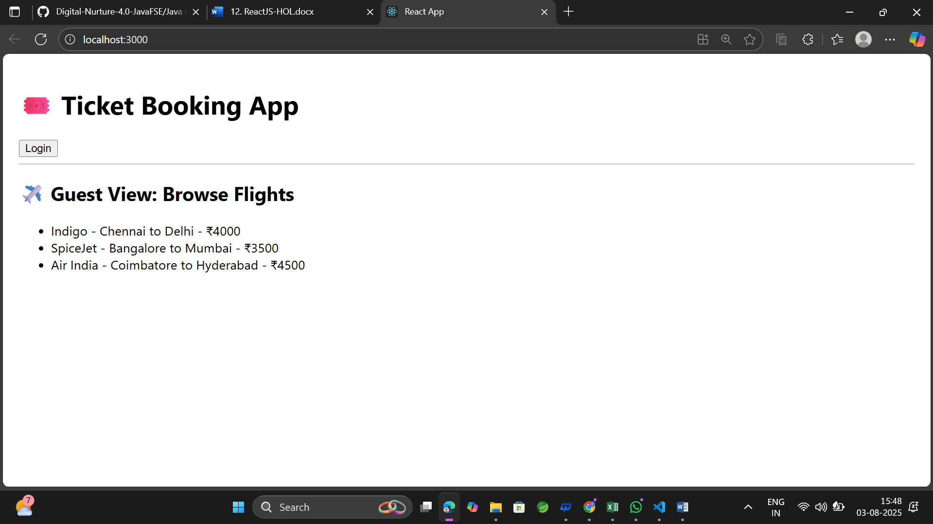
Logout:
